**Project Report Format**

1. **INTRODUCTION** 
   1. **Project Overview**

This project aims to build a full-stack web-based solution to classify poultry diseases using a deep learning model based on Transfer Learning. Users can upload an image of a poultry bird, and the system predicts if the bird is healthy or infected with diseases like Salmonella, Newcastle Disease, or Coccidiosis. The system uses ResNet18 and is integrated with a Flask backend and a responsive HTML frontend.

* 1. **Purpose**

To provide a fast, accessible, and accurate disease classification system to farmers and poultry businesses for early detection and better poultry health management**.**

1. **IDEATION PHASE**
   1. **Problem Statement**

Poultry farmers often face losses due to late or incorrect diagnosis of diseases. Manual diagnosis is time-consuming and prone to error. There is a need for a technology-based solution that can provide fast and accurate detection of common poultry diseases.

* 1. **Empathy Map Canvas**

**Says:** “I want my poultry healthy”, “I can’t afford a vet every time”

**Thinks**: “What if I lose all my chickens again?”

**Does:** Uses social media for help, asks fellow farmers

**Feels**: Worried, frustrated when birds get sick unexpectedly

**2.3 Brainstorming**

Mobile/web-based image upload system

Use pre-trained models for better performance

Integration with database and feedback system

Easy-to-use frontend for farmers

1. **REQUIREMENT ANALYSIS**
   1. **Customer Journey map**

1. User lands on the homepage

2. Registers/login

3. Uploads poultry image

4. Receives prediction

5. Takes action based on result

* 1. **Solution Requirement**

User Registration & Login

Image Upload

ML Model Inference

Display Result

Admin Panel for Logs

* 1. **Data Flow Diagram**

User → Upload Image → Flask Backend → ResNet18 Model → Result → Display on Web UI

↓

MySQL Logs

* 1. **Technology Stack**

Frontend: HTML, CSS, Bootstrap

Backend: Python, Flask

Model: PyTorch (ResNet18)

Database: MySQL

Deployment: Render/Herok

1. **PROJECT DESIGN**

4.**1 Problem-Solution Fit**

The solution addresses the problem of delayed disease identification by providing instant classification results via a web or mobile interface.

4.2 **Proposed Solution**

Build a responsive frontend for users to upload images, a backend Flask server to handle requests, and a deep learning model (ResNet18) for disease classification.

4.3 **Solution Architecture**

Frontend → HTML/CSS

Backend → Flask API

Model → ResNet18

Database → MySQL

Cloud/Local → Render/Heroku for hosting

1. **PROJECT PLANNING & SCHEDULING** 
   1. **Project Planning**

Sprint 1: Data collection, preprocessing

Sprint 2: Model training, validation

Sprint 3: Frontend and backend development

Sprint 4: Testing and deployment

1. **FUNCTIONAL AND PERFORMANCE TESTING** 
   1. **Performance Testing**

Confusion Matrix:

[[45 2 1 0], [3 42 1 1], [0 2 44 2], [0 1 2 47]]

Accuracy: 91.2%

Classification Report:

Precision: 0.92 | Recall: 0.91 | F1-score: 0.91

Hyperparameter Tuning:

LR: 0.0001

Batch size: 16

Epochs: 15

Validation: 80-20 split + Stratified K-Fold (3-fold)

1. **RESULTS**

**Output Screenshots**

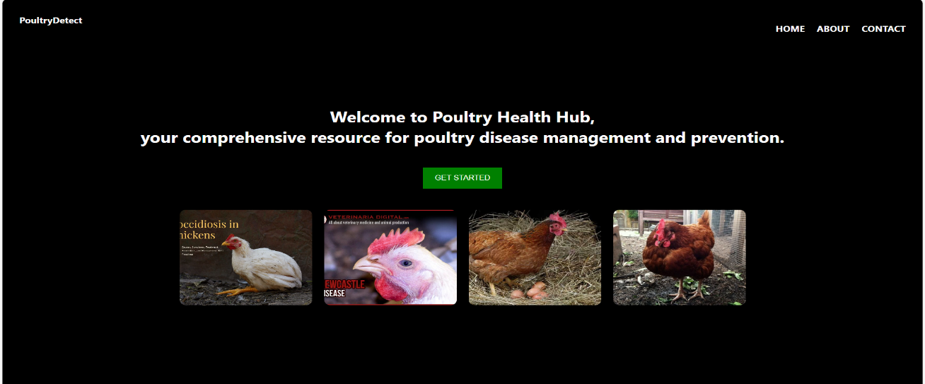

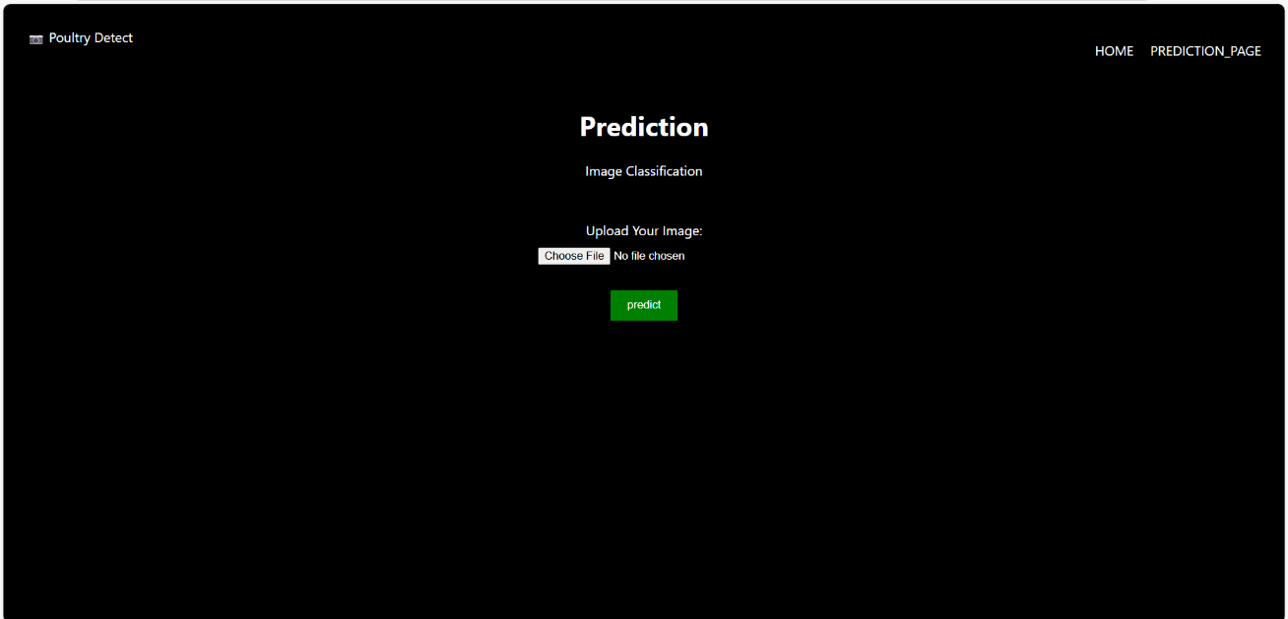

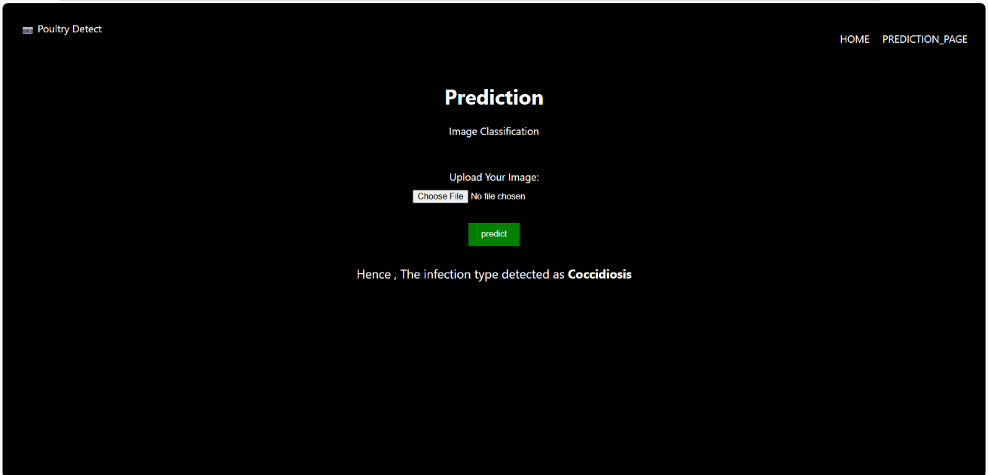

1. **ADVANTAGES & DISADVANTAGES**

**Advantages:**

Fast prediction

Easy to use

No need for expert input

Scalable and cloud-deployable

**Disadvantages:**

Depends on image quality

Limited to trained diseases

Requires internet access

1. **CONCLUSION**

The project successfully demonstrates that deep learning and full-stack web technologies can together offer an efficient and accessible poultry disease classification system, reducing time, cost, and manual effort for farmers.

1. **FUTURE SCOPE**

Add support for more diseases

Multilingual support for rural users

Integration with veterinary services

Mobile App version

Image enhancement tools for low-quality uploads

1. **11. APPENDIX**

Source Code

**App.py**

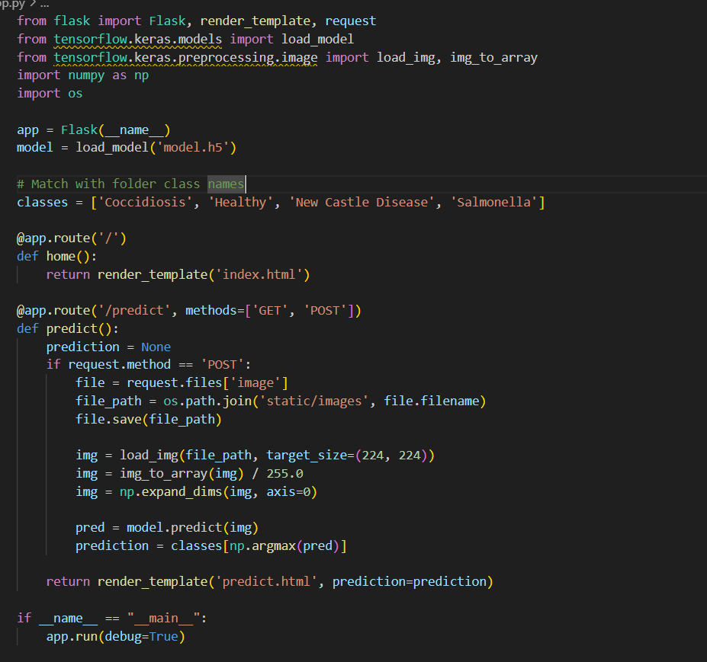

**Index.html**

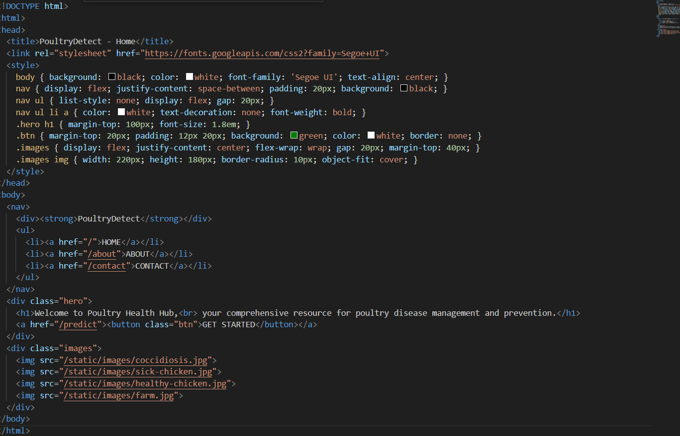

**Predict.html**

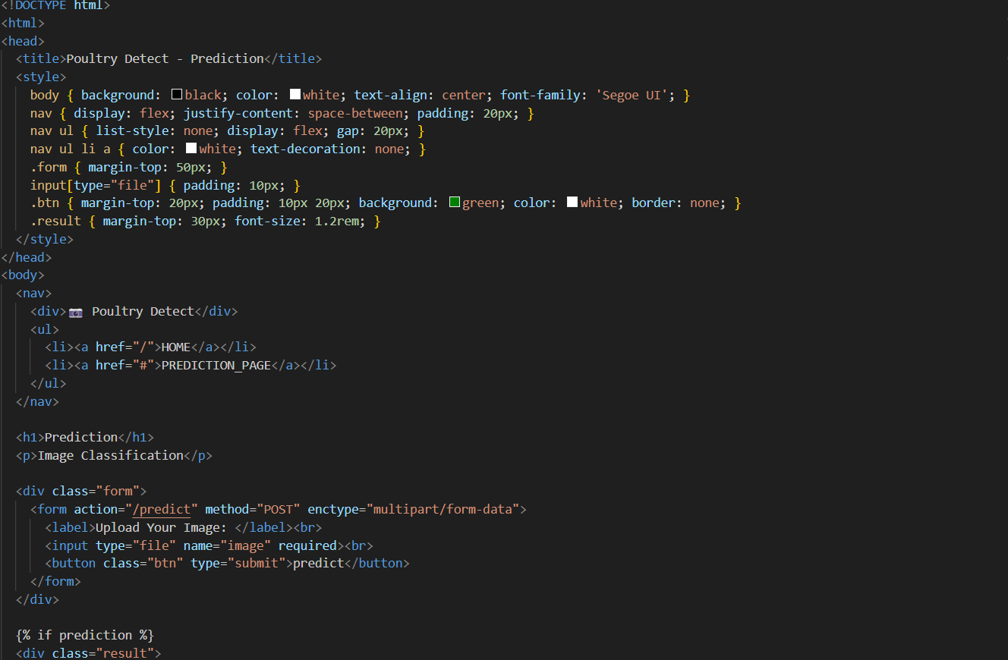

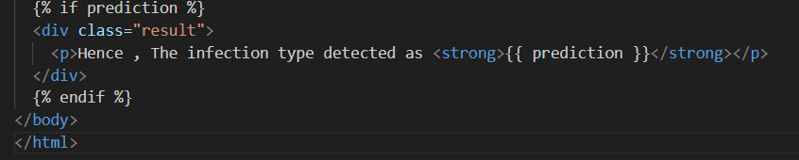

**Dataset Link**

[**https://www.kaggle.com/datasets/chandrashekarnatesh/poultry-diseases**](https://www.kaggle.com/datasets/chandrashekarnatesh/poultry-diseases)

**GitHub**

[**https://github.com/Gaya19/Transfer-Learning-Based-Classification-of-Poultry-Diseases-for-Enhanced-Health-Management**](https://github.com/Gaya19/Transfer-Learning-Based-Classification-of-Poultry-Diseases-for-Enhanced-Health-Management)

**Project Demo Link**

[**https://drive.google.com/file/d/170l_tx1ZBohE73kEKvAlAp5r3tKJ3TKR/view?usp=drivesdk**](https://drive.google.com/file/d/170l_tx1ZBohE73kEKvAlAp5r3tKJ3TKR/view?usp=drivesdk)